Employee build ;
Server connecting command ;
ssh -i ssh-key -p 2222 deploy_admino8@192.168.1.163
[OR]
ssh -i ssh-key -p 2222 deploy_admin08@192.168.1.163

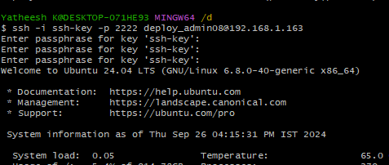

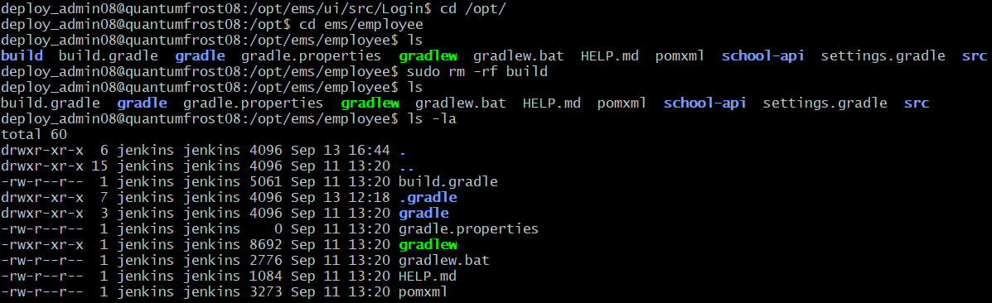

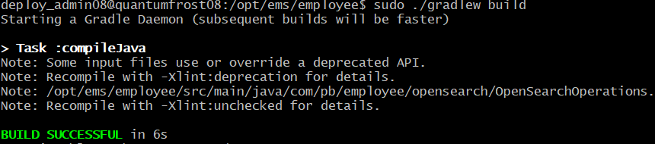

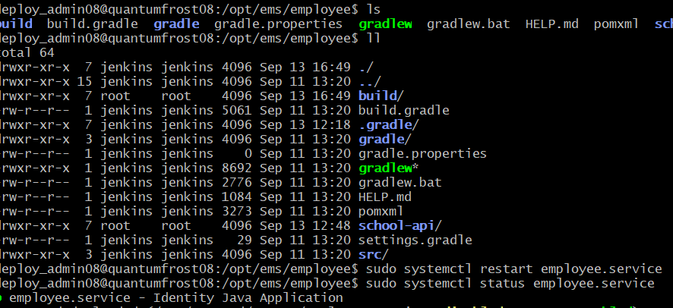

Ui build ;

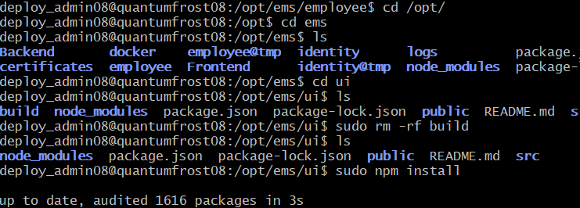

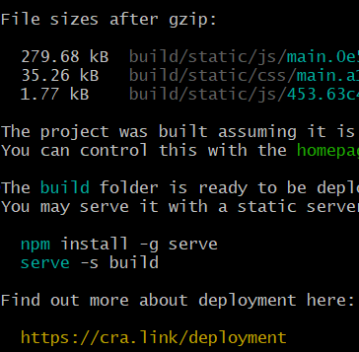

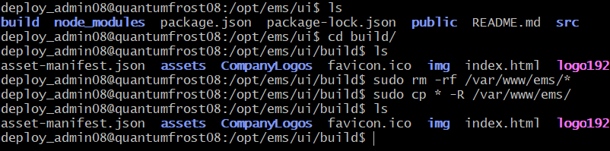Completed build ui

Ems application docker folder in said files.
docker file ;
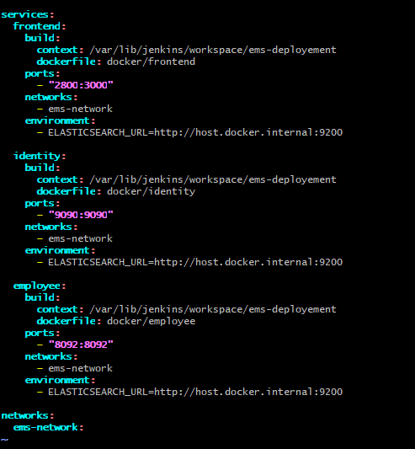

Employe file
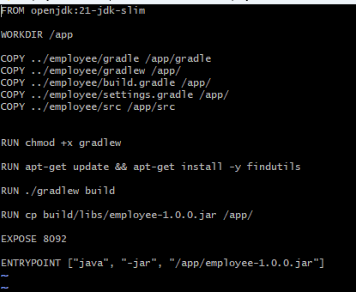

Frontend file ;
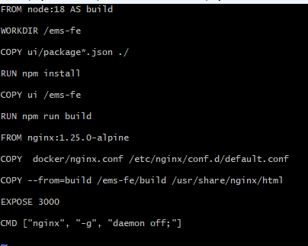

Identity file ;
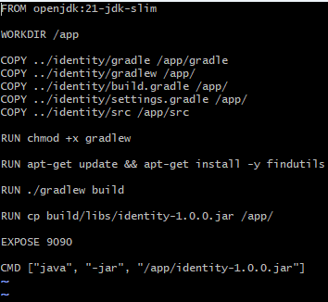
Nginxfile ;
